**d**esign PDA for the input a^nb^n

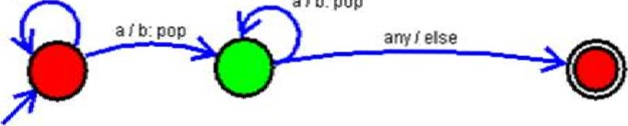

alb:

pop

